Unit 5.1 Assignment: Creating and Refining Technical Instructions

Zachary Howell
School of Arts and Sciences, Post University
CIS 311: Technical Writing in CIS
Professor Vincent Tran
June 7, 2026

Unit 5.1 Assignment: Creating and Refining Technical Instructions
Task selected: Troubleshooting a home Wi-Fi connection when a laptop or phone will not connect to the internet.
Audience: General home users with basic computer or smartphone experience.
Goal: Restore internet access by checking the device, Wi-Fi network, router, and basic settings before contacting support.
Terms Used in These Instructions
Wi-Fi: A wireless network that lets your device connect to the internet without a cable.
Router: The box that sends the Wi-Fi signal through your home.
Modem: The box that brings internet service from your provider into your home. Some homes use one combined modem/router.
SSID: The Wi-Fi network name that appears on your device.
Troubleshooter: A built-in tool that checks common connection problems and suggests repairs.
Materials Needed
- Laptop, tablet, or smartphone
- Wi-Fi network name and password
- Access to the router or modem/router
- A clock or timer

Visual Aid: Wi-Fi Troubleshooting Flowchart
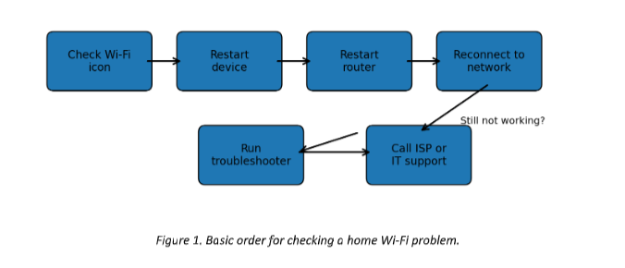
Revised Step-by-Step Instructions
- Check the Wi-Fi icon on your device. Look for the Wi-Fi symbol on your screen. If the icon is missing or has a slash through it, Wi-Fi may be turned off.

- Turn Wi-Fi off and back on. Open the Wi-Fi settings on your device. Switch Wi-Fi off. Wait 10 seconds. Switch Wi-Fi back on. This refreshes the connection.

- Confirm that you are choosing the correct network name. Look for your home network name, also called the SSID. Select the network that matches the name printed on your router label or saved in your records.

- Enter the Wi-Fi password carefully. Passwords are case-sensitive. This means capital letters and lowercase letters must match exactly. Check for confusing characters such as 0 and O or 1 and l.

- Restart your device. Power off the laptop, phone, or tablet. Wait 30 seconds. Turn it back on and try the Wi-Fi connection again.

- Restart the router or modem/router. Unplug the power cord from the router. Wait 60 seconds. Plug the power cord back in. Wait 3 to 5 minutes for the lights to become steady.

- Check the router lights. A steady power light usually means the router is on. A steady internet or online light usually means it has service. A blinking Wi-Fi light usually means the router is sending a signal.

- Move closer to the router. Try connecting from the same room as the router. Thick walls, metal objects, and distance can weaken the signal.

- Forget the network and reconnect. In Wi-Fi settings, select your network. Choose Forget, Remove, or Forget This Network. Then select the network again and re-enter the password.

- Run the device network troubleshooter. On Windows, go to Settings > Network & internet > Advanced network settings > Network troubleshooter. On many phones, restart the device and use the Wi-Fi settings screen to check connection details.

- Test another website or app. Open a different website or app. One website may be down even when your internet works.
- Contact your internet provider or IT support. Call for help if no device connects, the internet light stays off, or the router shows red warning lights after restarting.

Troubleshooting Tips
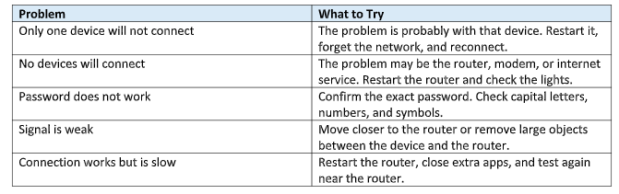

Usability Test Summary
To test the instructions, I asked my daughter to follow the original version exactly as written. I observed silently and wrote down where the reader paused, asked questions, or repeated a step. My daughter completed the task, but the test showed that several parts needed clearer wording.

- She was unsure what “SSID” meant until it was explained.
- She almost pressed the router reset button instead of unplugging the power cord.
- She did not know how long to wait after plugging the router back in.
- She wanted a quick way to decide whether the issue was with one device or the whole home network.

Reflection and Revisions
After testing the instructions, I revised them to make the task easier for a general home user to follow without extra explanation. The biggest change was adding definitions for technical terms such as Wi-Fi, router, modem, and SSID. These terms may seem simple to someone who uses technology often, but they can confuse a reader who only wants to fix the problem quickly.
I also added a clear warning not to press the router reset button. During the test, my daughter thought restarting the router might mean pushing the reset button. That could create a bigger problem because a full reset can erase the network settings. I changed the wording to say “unplug the power cord,” wait 60 seconds, and then plug it back in. I also added the instruction to wait 3 to 5 minutes for the lights to become steady.
Testing helped me see that instructions must be written from the reader’s point of view, not the writer’s point of view. A step that seems obvious to the writer may not be obvious to the user. I learned that strong technical writing uses short sentences, numbered steps, warnings, definitions, and visuals to reduce confusion. The flowchart and troubleshooting table also make the document more usable because readers can quickly find the next action when something does not work.

